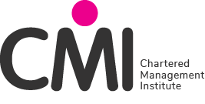
CMI CENTRE STATEMENT/DECLARATION OF AUTHENTICITY

This statement must be completed and electronically attached to the completed assessment(s) being submitted to CMI. Any submission(s) that do not have this signed statement are inadmissible.

Section 1 -

Centre

Name of Responsible Person submitting Statement / Declaration Of Authenticity

CMI Qualification

Unit Number

Learner CMI Number

I _____________________________________ confirm that the learners in section 2 of this form are registered at this Centre on a programme of study leading to a Chartered Management Institute (CMI) qualification and I am satisfied that, to the best of my knowledge, the work produced is solely that of the learner(s) and confirm that Sections 1 & 2 of this form have been checked and completed before submission.

I confirm that the learners have completed a CMI Learner Statement/Declaration Of Authenticity and that this will be submitted as part of any evidence submitted to CMI for either Marking or Moderation purposes.

I understand that a false declaration is a form of malpractice.

Centre Signature*

Date Submitted

*Please note electronic signatures are accepted

Section 2 -

 | Learner’s CMI Number | Learners Name
1
2
3
4
5
6
7
8
9
10

